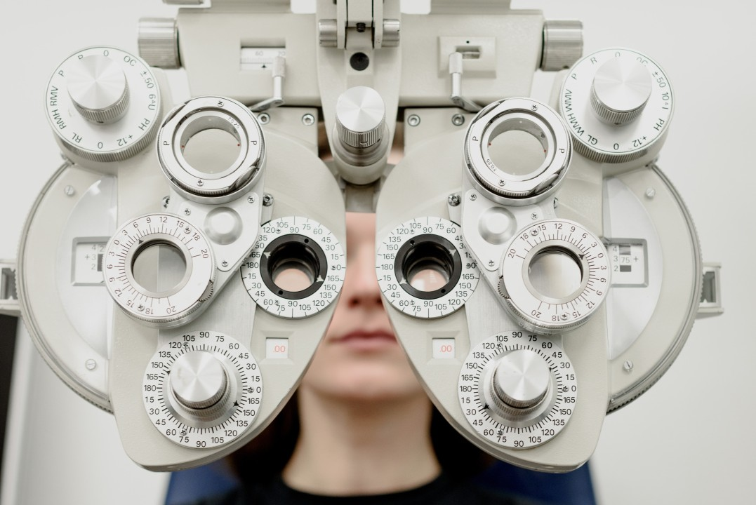

Care through an Anthropological Lens: Anthropologists' Unique Contributions to the Medical Field


Carmen Luke

Transitie Antropoloog met een passie voor het bevorderen van sociale gerechtigheid 🔬| FIXbrigade Nederland | Aanpakker Energiearmoede
8 augustus 2023
In the realm of medical (social) work, where understanding patients' social realities is crucial, anthropologists bring a unique lens to patient care. It may seem like an unlikely pairing, but the integration of anthropology and medical (social) work can provide a holistic, empathetic, and culturally sensitive approach to patient care. Discover how anthropologists can transform the medical field to better meet the needs of diverse patient populations.
Holistic Understanding of Patient Experience
Anthropologists, with their training in studying human behaviour and social interactions, can provide a holistic view of patients' experiences. They consider the cultural, social, and psychological contexts that impact health and illness, ensuring that care plans acknowledge and address these factors. This comprehensive approach can lead to more effective interventions and better patient outcomes.
Cultural Sensitivity in Patient Care
Cultural understanding is critical in a diverse healthcare environment. Anthropologists, trained in cross-cultural communication, can help healthcare providers deliver culturally competent care. This sensitivity can enhance patient communication, foster mutual understanding, and improve patient satisfaction and adherence to care plans.
Empathy in Patient-Provider Relationships
Anthropologists bring empathy to the healthcare setting, fostering stronger patient-provider relationships. Their deep understanding of human behaviour allows them to empathize with patients' experiences and emotions, which can contribute to building trust, improving communication, and enhancing the overall patient experience.
Qualitative Research for Patient Insights
Anthropologists are well-versed in qualitative research methods, which can provide valuable insights into patients' perceptions, experiences, and needs. These insights can inform patient-centred care, leading to personalized interventions that respect patients' values and improve their health outcomes.
Ethical Considerations in Patient Care
In a healthcare setting, ethical considerations are paramount. Anthropologists can bring an ethical perspective to patient care, ensuring that medical social work practices respect patients' autonomy, dignity, and cultural values. This ethical lens can help prevent potential ethical dilemmas and promote patient rights.
Advocacy for Health Equity
Anthropologists, with their understanding of social disparities, can advocate for health equity. They can help identify and address social determinants of health, advocating for vulnerable populations and working towards systemic changes that promote health equity.
The intersection of anthropology and medical (social) work offers a transformative approach to patient care, one that is holistic, empathetic, culturally sensitive, and ethically conscious. If you're looking to enhance your medical practices, consider the invaluable contributions that anthropologists can make. Their unique perspectives and skills can help healthcare providers better understand and meet the needs of their diverse patient populations.

Be sure to join us next month as we continue this series ‘Anthropos at work’, highlighting different professions where the skills and perspectives of anthropologists provide immense value. Furthermore, if you want to explore more of the world of applied anthropology, you can also follow our other series through the Antropologen Beroepsvereniging: Werkgroep Arbeidsmarkt page! And let me know – what job do you think I should cover next?
hashtag#Anthropologists hashtag#Inspiration hashtag#Medical hashtag#CareGiving hashtag#PatientCare hashtag#AppliedAnthropology hashtag#AnthroposAtWork

