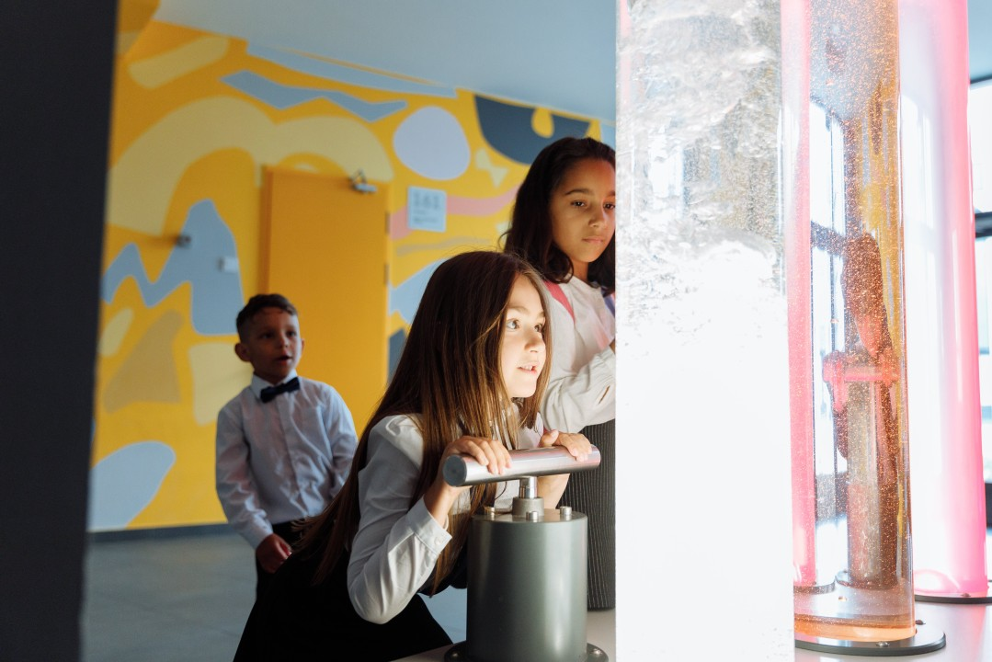

Unconventional Wisdom: How Anthropology Can Revolutionize Education


Carmen Luke

Transitie Antropoloog met een passie voor het bevorderen van sociale gerechtigheid 🔬| FIXbrigade Nederland | Aanpakker Energiearmoede
31 oktober 2023
Education is often seen as a structured process, with defined goals and curricula. But what if we looked at education through a different lens, one that challenges the status quo and enriches the learning experience? The anthropological skillset, often considered unconventional in this field, offers a fresh perspective to transform education. Let's explore how anthropologists can infuse creativity, empathy, and cultural awareness into the realm of learning.
Anthropology and the Art of Teaching
Anthropologists are skilled in understanding the complexities of human behaviour and cultural diversity. These skills can be invaluable for educators. By adopting an anthropological approach, educators can design curricula that engage students in a deep exploration of human societies, their cultures, and the challenges they face. This shifts the focus from rote memorization to critical thinking and meaningful learning.
Cultural Sensitivity in the Classroom
In an increasingly diverse world, cultural sensitivity is crucial in education. Anthropologists can guide educators in creating inclusive classrooms that respect and celebrate different cultural perspectives. This not only enhances the educational experience but also prepares students for a globalized society where intercultural communication and collaboration are vital.
Promoting Critical Thinking and Social Awareness
Anthropologists excel in promoting critical thinking and social awareness. By encouraging students to analyse and question the world around them, educators can help cultivate a new generation of informed and engaged citizens. Anthropological methods, such as ethnographic research, can be adapted to classroom activities that encourage students to investigate and understand complex issues.
Cross-Cultural Understanding in the Digital Age
With the world becoming increasingly interconnected through technology, cross-cultural understanding is more important than ever. Anthropologists can help educators design programs that foster this understanding. By bridging cultural gaps and promoting dialogue, educators can prepare students to navigate the globalized digital landscape effectively.
Adaptive Teaching Methods
The ability to adapt teaching methods to different cultural and social contexts is a valuable trait of anthropologists. Educators can draw from this adaptability to engage students with diverse learning styles. This personalization of teaching can make education more effective and enjoyable for a wider range of students.
The incorporation of anthropological skills into education can create a dynamic and engaging learning environment. By challenging the status quo and shifting the focus from memorization to critical thinking and cultural understanding, anthropologists can help educators and students re-imagine education. The result is a more inclusive, creative, and culturally aware educational system that prepares students not just for exams but for life in an ever-changing global society.

Keep an eye out for our monthly series ‘Anthropos at Work', where we delve into the myriad ways anthropological skills enhance various professions, fostering fresh perspectives and breaking boundaries. If you want to explore more of the world of applied anthropology, you can also follow our other series through the Antropologen Beroepsvereniging: Werkgroep Arbeidsmarkt page!
#Education #Anthropology #TransformativeLearning #CulturalAwareness #AppliedAnthropology #AnthroposAtWork

