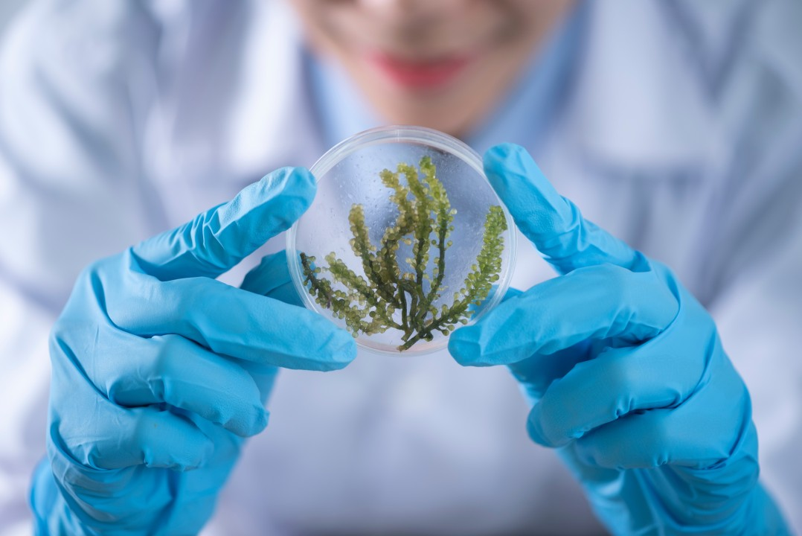

Bridging Worlds: How Anthropological Skills Enhance Careers in Ecology and Biology


Carmen Luke

Transitie Antropoloog met een passie voor het bevorderen van sociale gerechtigheid 🔬| FIXbrigade Nederland | Aanpakker Energiearmoede
21 september 2023
In the fields of ecology and biology, where the natural world and its inhabitants are under constant study, an anthropological skillset may not seem an obvious fit. However, the integration of anthropology into these sciences can bring fresh perspectives, nuanced insights, and a deeper understanding of the complex interactions between humans and their environment. Explore how anthropologists can enrich careers in ecology and biology, unveiling the hidden connections between the conventionally separated nature and culture.
Cultural Ecology: A Multidimensional View
Anthropologists are trained to study the intricate relationships between cultures and their environments. When applied to ecology, this skillset offers a multidimensional view of how human cultures interact with and impact ecosystems. Understanding these connections is vital in addressing today's ecological challenges, such as climate change and biodiversity loss, which essentially have cultural roots.
Indigenous Knowledge
Indigenous communities around the world hold profound knowledge of their local ecosystems. Anthropologists can help bridge the gap between indigenous knowledge and contemporary ecological science. By acknowledging and respecting indigenous perspectives, ecologists and biologists can learn valuable lessons about sustainable cultural practices and thought patterns.
Community-Based Conservation and Collaborative Research
Anthropologists excel in working closely with communities and stakeholders. In ecology and biology, this collaborative approach can be a game-changer. Anthropologists can facilitate community-based conservation efforts, ensuring that local knowledge and concerns are integrated into conservation strategies. This not only enhances the chances of success but also promotes social equity in conservation practices.
Behavioural Ecology: Understanding Human-Nature Interactions
In the realm of behavioural ecology, anthropologists bring their expertise in understanding human behaviour and social dynamics to the study of non-human animals. They can shed light on the cultural significance of non-human animals and how human actions impact animal behaviour and vice versa. This holistic perspective can lead to more effective conservation strategies.
Qualitative Research in Field Studies
Anthropologists are well-versed in qualitative research methods, such as participant observation and in-depth interviews. These techniques can complement quantitative ecological studies by providing rich context and insights into both the human and non-human dimensions of environmental issues. Anthropological fieldwork can uncover the motivations, values, and beliefs that influence human interactions with the environment.
Cross-Cultural Communication in Global Conservation
In a world where conservation efforts are increasingly global, effective cross-cultural communication is paramount. Anthropologists can serve as mediators and interpreters, helping scientists and conservationists communicate with diverse communities around the world. This fosters collaboration and ensures that conservation strategies are culturally sensitive and contextually relevant.
The integration of anthropology into ecology and biology brings a holistic, culturally sensitive, and community-oriented perspective to the study of the natural world. Anthropologists can help ecologists and biologists navigate the intricate web of human-nature interactions, fostering more effective sustainability efforts and a deeper understanding of our role in the intricate ecosystem.
Consider the unique insights and skills that anthropologists can bring to your career in ecology and biology. Whether you're studying wildlife behaviour, working on conservation projects, or engaging with communities, anthropological expertise can open new doors and illuminate hidden connections.

Stay tuned for more articles in this monthly series, where we explore the diverse roles where anthropologists play a vital and often unexpected role. Each month, we'll uncover how anthropological skills enhance various professions, making the world a more interconnected and informed place. Furthermore, if you want to explore more of the world of applied anthropology, you can also follow our other series through the Antropologen Beroepsvereniging: Werkgroep Arbeidsmarkt page! #Anthropologists #Inspiration #Biology #Ecology #AppliedAnthropology #AnthroposAtWork

